MIDTOWNERS SUNSHINE OF THE WEEK ► January 4, 2008
Anniversary of Rtn. Basu and Lily on January 15th
Anniversary of Rtn. Mahendra and Monica on January 17th

SPEAKER OF THE WEEK ► Ms. Isabelle Pastor
THEME | Shechen Clinic
Ms. Isabelle Pastor, a 35 years old lawyer from France joined a French NGO in Nepal called "Planete Enfants" as its director in July 2002, after practicing law in France for 4 years. This organization works on child protection, essentially on child trafficking. In January 2006, the Shechen Clinic offered her to work with them, and she joined the clinic as the deputy director to Dominique Marchal, a Belgian lady who was the founding director of the clinic. In October 2007, she was appointed the Managing Director of the clinic.

UPCOMING SPEAKERS ► PREVIEW
DATE | SPEAKER | THEME
Jan 18th | Dr. Saurav Dev Bhatta | Deadly sins of Statistical Misrepresentation in the Media
Jan 25th | Chandra Morgan | To be confirmed
Feb 1st

THE MID-TOWN CLUB ► NEWS
Last Week’s Speakers
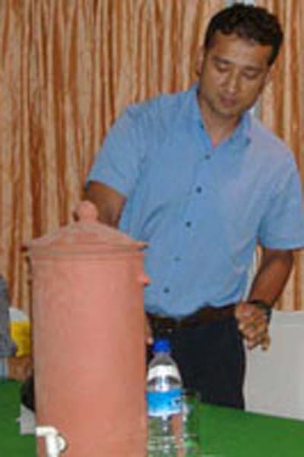
Rtn. Hem Pokharel (RC Sudbury, USA) and Mr. Hari Govinda Prajapati demonstrated a water-filter making process that was developed by Solutions Benefiting Life (SBL), a non-profit organization based near Boston, USA. Rtn. Hem has been working for SBL for 4 years as a project manager at its Boston facility, while Mr. Prajapati has been working for SBL for more than 3 years as a project manager and producer of SBL units for Nepal. They informed that SBL system water treatment meets WHO standard and ensures 99.99 percent bacteria free drinking water to common masses at a low cost and with simplified filter. Studies have revealed that the use of filtered water for drinking has reduced water borne diseases among users by 40%. The cost of the locally made filter is Rs. 400 (2007) and the flow of filter is 4.5 litres/hr.

Rotary Art Competition 2007
The Vocational Service Avenue of Rotary Club of Kathmandu Mid-Town organized an art workshop and a competition last in December 2007 under Serve Build a New Nepal theme. The organizing committee was chaired by our Vocational Service Director Saroj Shrestha, and consisted of President Walter, PP William, PP Komal, Rtn. Govinda, and Rtn. Som. Mrs. Sharada Chitracar, Spouse of PP Komal, was the Program Coordinator. President of Fine Art Critics’ Society, Rtn. Ramesh was also member of the committee. A total of 52 students from 25 secondary schools participated in the event that included an art workshop held on December 15th at Shuvatara School, and an exhibition held from December 28-30th at the Nepal Art Council Gallery.
Mrs. Sharada Chitrakar sponsored cash awards in memory of her late father Tejbahadur Chitrakar, art teacher and a pioneer of contemporary art in Nepal. The awards totaling Rs 10,000 were – First prize Rs 4,000; Second prize Rs 2,500; Third prize Rs 1,500; four Consolation prizes of Rs 500 each.
The exhibition was inaugurated in a ceremony by H.E. Mr. Sumith Nakandala, the Sri Lankan ambassador to Nepal. He handed over certificates for seven best paintings along with cash awards. Certificates of participation were distributed to all participating schools and students. Certificates of Recognition were distributed to the judges, partner organizations and the workshop venue provider. Rtn Saroj gave welcome address, Program Coordinator Mrs. Sharada Chitracar presented the report of the competition, DGN appreciated the program, and President Walter proposed a vote of thanks. Rtn. Govinda was the MC of the program.

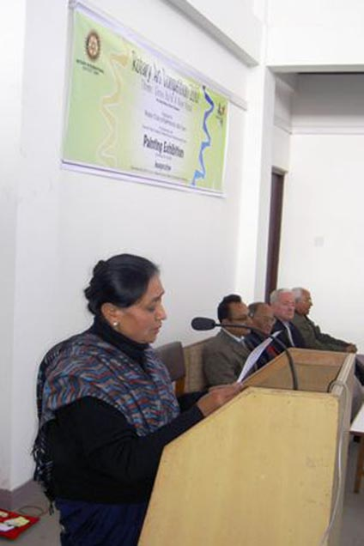  Program Coordinator Mrs. Sharada Chitracar presenting report on the competition | 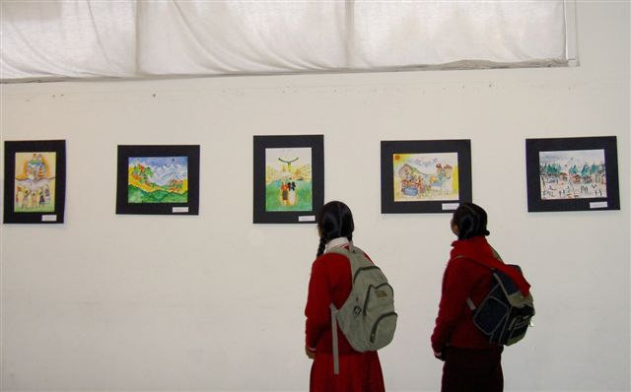  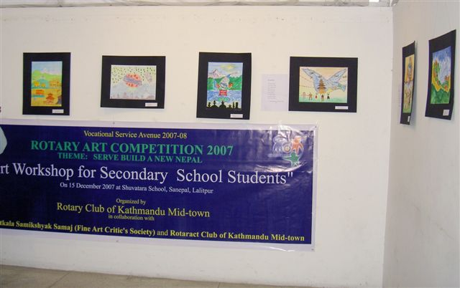  Glimpses of the exhibition | 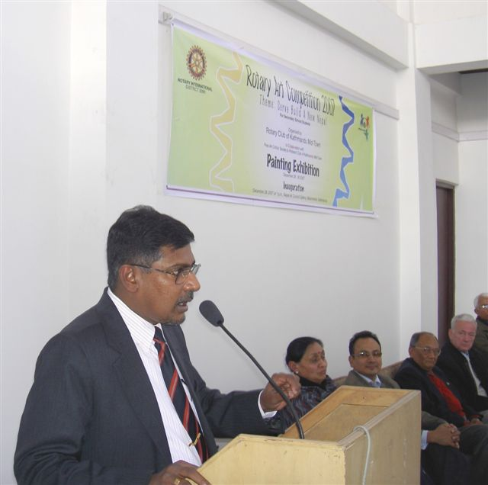  Chief Guest H.E. Mr. Sumith Nakandala addressing the meet
Rota Quiz 2008
Our club will be represented by the following team at this year’s Rota Quiz:
PP Ajaya Sthapit – Team Leader
PP Jyotsna Shrestha
PE RR Shrestha
Rtn. Rabi Karmacharya
Rtn. Som Pudasaini
The first round of the contest will be held on January 11th at 3PM in Wunjala Restaurant, with the finals planned for January 19th. As you may know, our club is the defending champion of the Rota Quiz competition.

Lunch and Fellowship
The International Dinner Series is being revived after a long hiatus.
DATE: 12 January, 2008 Saturday
PLACE: "Jagate Chwela Restaurant ", Bhaktapur
TIME: 11:15 AM Assemble outside The Art Council at Babar Mahal to carpool
11:30 AM Leave
12:00 PM Lunch
COST: Rs. 250/ person approximately plus drinks ( If you prefer wine, please bring your own)
For further information please contact Rtn. Govind Chipalu at 4251503.

Editor: Rabi Karmacharya, Club Service Director email: rabikarma@gmail.com

----- Original Message -----
From: "Rabi Karmacharya" <rabikarma@gmail.com>
To: <undisclosed-recipients:>
Sent: 10 January, 2008 15:03
Subject: BC Vol 17 07-08

Here is this week's Breakfast Chatter.
-Rabi

